Transportation Fuel Viability Calculations
Essential Question: Which fuel sources have the most potential to replace fossil fuels in the transportation sector?
Figure 1: Energy density of various energy sources. Values are given in MJ/kg. Methane is differentiated from natural gas in this case in reference to methane generated by landfills and other decomposition sources. From https://people.hofstra.edu/geotrans/eng/ch8en/conc8en/energycontent.html
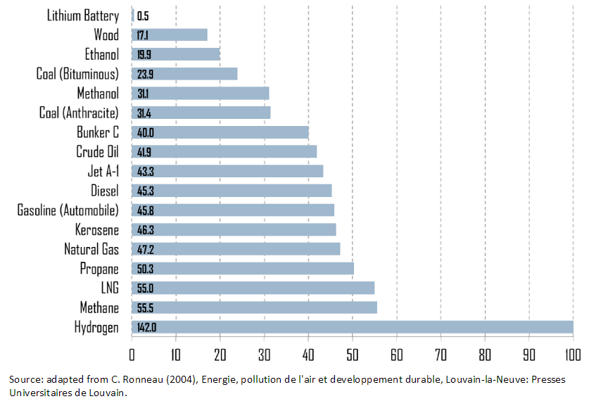
0.56
*
*
*

*
*
*
*
*
*
- Assume that each fuel with an “*” is a candidate for use in personal vehicles. Convert the energy density of each fuel source with an “*” into kWh/kg. 1 MJ = 0.28 kWh. SHOW ALL CALCULATIONS.
Hydrogen: ________ kWh/kg
Methane: ________ kWh/kg
Propane: ________ kWh/kg
Natural Gas: ________ kWh/kg
Gasoline: ________ kWh/kg
Diesel: ________ kWh/kg
Methanol: ________ kWh/kg
Ethanol: ________ kWh/kg
Lithium Battery: ________ kWh/kg
- Assume that the equivalent of 1.0 kWh is enough power to allow a typical personal vehicle to travel 3.1 miles at a speed of 60 mph. Calculate the number of miles each fuel will power a typical vehicle using just 1.0 kg of fuel. SHOW ALL CALCULATIONS.
Hydrogen: ________ mi/kg
Methane: ________ mi/kg
Propane: ________ mi/kg
Natural Gas: ________ mi/kg
Gasoline: ________ mi/kg
Diesel: ________ mi/kg
Methanol: ________ mi/kg
Ethanol: ________ mi/kg
Lithium Battery: _______mi/kg

The values calculated in step two are assuming a perfect, or 100% thermal efficiency. As you know, the 2nd law of thermodynamics states that this is impossible. Figure 2 below lists each of the above fuel sources and with their corresponding percent efficiency. For example, an efficiency rating of 50% would mean that ½ of the energy is actually used to power the vehicle.
Figure #2: Efficiency ratings
Fuel | % efficiency
Lithium ion battery | 88%
Diesel | 42%
Gasoline | 28%
Hydrogen | 42%
Ethanol | 31%
Methanol | 40%
Natural Gas | 40%
Methane | 40%
Propane | 36%

- Use the percent efficiency for each fuel source to re-calculate the number of miles each fuel will power a typical vehicle using 1.0 kg of fuel. SHOW ALL CALCULATIONS.
Hydrogen: ________ mi/kg
Methane: ________ mi/kg
Propane: ________ mi/kg
Natural Gas: ________ mi/kg
Gasoline: ________ mi/kg
Diesel: ________ mi/kg
Methanol: ________ mi/kg
Ethanol: ________ mi/kg
Lithium Battery: _______mi/kg

- Rank each fuel 1-9 (9 is best) on the Fuel Viability Matrix for the miles/kg category.
While it appears that hydrogen and methane are clearly the most energy dense, another important factor to consider is the space requirements. Hydrogen and methane, while containing a large amount of energy per kilogram, also require a lot of space for storage due to their relatively low mass density.
Figure 3 below shows the density of each fuel source with regard to its mass to volume ratio. Use these values to calculate the miles/liter value for each fuel source.
Figure #3: Mass density of various fuel sources
Compressed H₂ gas | .025 kg/L
Gasoline | 0.75 kg/L
Compressed natural gas | 0.13 kg/L
Compressed methane | 0.12 kg/L
Compressed propane | 0.493 kg/L
Diesel | 0.833 kg/L
Lithium battery | 3.6 kg/L
Ethanol | 0.789 kg/L
Methanol | 0.792 kg/L

- Calculate the values for each fuel in miles per liter. SHOW ALL CALCULATIONS.
Hydrogen: ________ mi/L
Methane: ________ mi/L
Propane: ________ mi/L
Natural Gas: ________ mi/L
Gasoline: ________ mi/L
Diesel: ________ mi/L
Methanol: ________ mi/L
Ethanol: ________ mi/L
Lithium Battery: _______mi/L:

- Rank each fuel 1-9 (9 is best) according to the values calculated in step five and write the ranking on the accompanying matrix.

Another important factor to consider in this review is the actual cost to produce each of the fuel sources. This is difficult to assess because the actual costs can vary greatly depending on methods, location, etc. The values below are average costs per kilogram.
Figure #4: Fuel costs per kilogram
Fuel Source | Cost
Hydrogen | $1.29/kg
Gasoline | $1.05/kg
Ethanol | $.85/kg
Methanol | $.55/kg
Natural gas | $1.85/kg
Methane | $3.08/kg
Lithium ion battery (cost to charge) | $.02/kg
Diesel | $1.09/kg
Propane | $2.05/kg

- Using the values in the above table, calculate the cost per mile ($/mile) to use each of the above sources in a personal vehicle.

Hydrogen: ________ $/mi
Methane: ________ $/mi
Propane: ________ $/mi
Natural Gas: ________ $/mi
Gasoline: ________ $/mi
Diesel: ________ $/mi
Methanol: ________ $/mi
Ethanol: ________ $/mi
Lithium Battery: _______$/mi

- Rank each fuel 1-9 (9 is best) on the Fuel Viability Matrix for the cost/mile category.

ERoEI: Energy Return on Energy Invested
The fundamental idea of the ERoEI index is to determine the net energy obtained from a particular source. ERoEI is often expressed as a ratio of energy output to energy input. In other words, how does the amount of energy we get out of a particular source compare to the amount of energy required to mine, process, refine, or synthesize the source or fuel. An ERoEI ratio of 1:1 would mean that there is a net energy gain of zero, whereas a ratio of 2:1 would mean that twice as much energy is gained from a source as is needed to extract or process it.
Figure #5: ERoEI Comparison
Fuel | ERoEI
Hydrogen | 0.4
Lithium Ion Battery | 8.2
Gasoline | 14.5
Diesel | 14.5
Natural gas | 10
Methane | 10
Ethanol | 4
Methanol | 2.6
Propane | 8

- Rank each fuel 1-9 (9 is best) on the Fuel Viability Matrix for the ERoEI category.
Weighted Total:
Observe the values in your fuel viability matrix. Use the following formula to calculate your weighted total for each fuel source.
(Subtotal 1 x 0.25) + (Subtotal 2 x .75) = Weighted total
The values included in subtotal 2 are weighted more heavily because our primary goal is to look for sustainable, low-impact fuel sources. While the categories contributing to subtotal 1 are important indicators, they must be looked at through a lens which emphasizes long-term availability and environmental costs.

Hydrogen: ________
Methane: ________
Propane: ________
Natural Gas: ________
Gasoline: ________
Diesel: ________
Methanol: ________
Ethanol: ________
Lithium Battery: _______
Final Rankings (1 is best this time):

1)
2)
3)
4)
5)
6)
7)
8)
9)

Write a conclusion that addresses the essential question posted at the top of page #1. Use the claim, evidence, reason format to write your response.

