Background: Solar panels are most efficient when south facing. However, not all of the parking at City Hall is south facing. In order to accurately estimate the electrical output of the two design options you will need to know how electrical output changes with azimuth and tilt.

Questions: 1) How is the amount of electricity harvested from a solar panel affected by the tilt of the solar panel?

2) How is the amount of electricity harvested from a solar panel affected by the azimuth of the solar panel?

Hypothesis: 1) __________________________________________________________________
_______________________________________________________________________________

2)__________________________________________________________________
_______________________________________________________________________________

Materials:
Heat lamp 1 volt solar panel Protractor
Multimeter 30 /60 triangle Tape
12” Ruler 45 triangle Colored pencils (for graphing)
Graph paper

Procedure:
1) Set the heat lamp up so that it is approximately 4” off the ground (or table) and is parallel with the floor (or table). The heat lamp represents the sun and will be 180 degrees.
2) On a piece of plain paper, use the protractor to draw a compass rose (example below). Label N, NE, E, SE, S, SW, W, and NW on the paper.
3) Place the ruler on the ground (or table) perpendicular to the lamp. 0” should be aligned with the bottom of the lamp. Place the compass rose from step 2 so that the south aligns with the ruler (and the heat lamp). Tape the paper down so that the center of the compass rose is 12”from the heat lamp. Remove the ruler.
4) Place the solar panel at a 0 degree tilt (flat on the ground or table) in the center of the compass rose. Attach the red clip on the multimeter to the red wire on the solar panel and the black clip on the multimeter to the black wire on the solar panel. Turn the multimeter to the setting V$∼$ 200. Keeping the solar panel flat, rotate it around the compass rose. (Note: Each voltage reading should be the same. If not, please ask your instructor for help.) Record the reading on Table 1.
5) Using the 30/60/90 triangle, align the solar panel on the 30 degree edge. Be sure to center the solar panel on the edge of the triangle so that the solar panel is perpendicular to the triangle edge. Place the triangle with the solar panel on the compass rose so that the solar panel is directly over the center of the compass rose and directly facing the heat lamp. Record the voltage reading on Table 1. Under 30 degree tilt, 180 south. Repeat this step for each direction on the compass rose and for each tilt specified in Table 1.

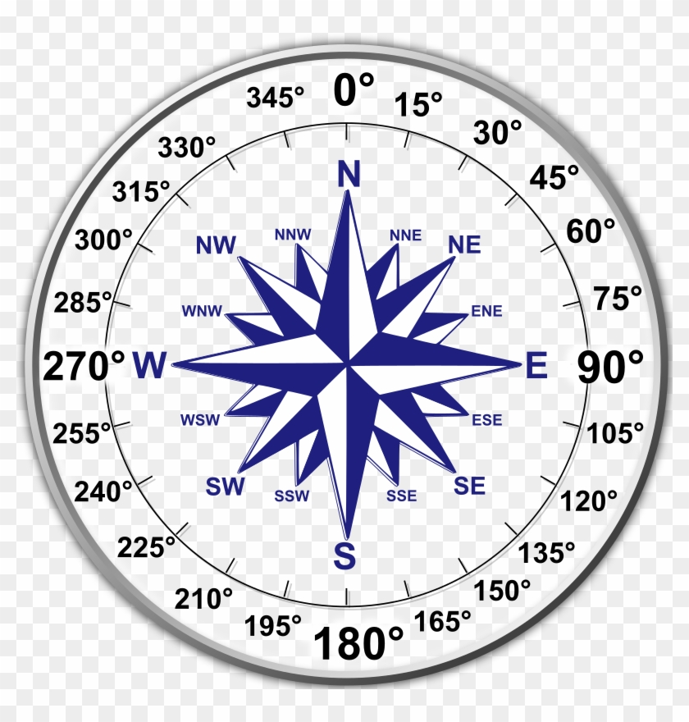
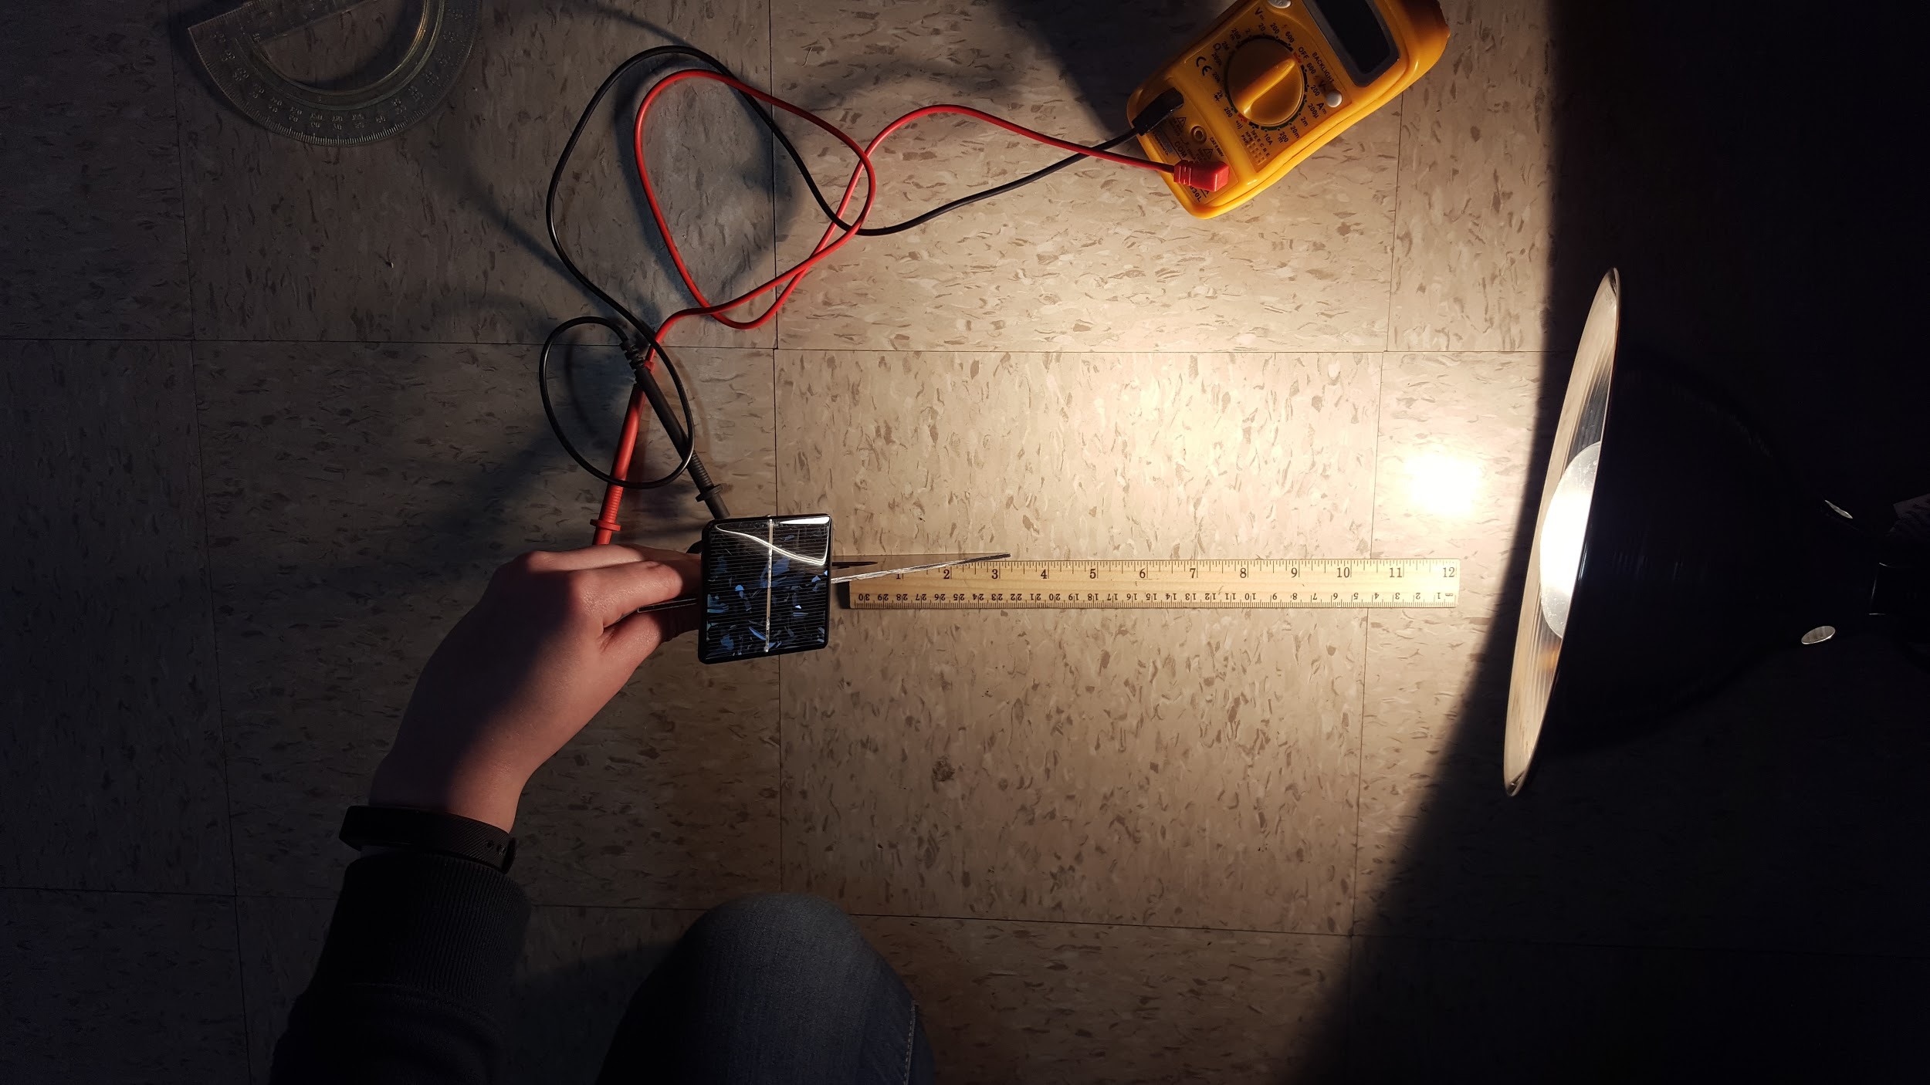
Example lab set-up Compass rose

Data Collection:
Table 1. Voltage at tilts and azimuths.
 | Azimuth
 | S | SW | W | NW | N | NE | E | SE
Tilt | 180 | 225 | 270 | 315 | 0 | 45 | 90 | 135
0
30
45
60
90

On a seperate piece of graph paper:
- Graph the relationship between the volts and azimuth for each tilt

What do you notice about the data?

Table 2. Percent change of voltage output with tilt
 | Azimuth
 | N | NE | E | SE | S | SW | W | NW
Tilt | 0 | 45 | 90 | 135 | 180 | 225 | 270 | 315
0 - 30
30 - 45
45 - 60
60 - 90

Table 3. Percent change with voltage output azimuth
 | Azimuth
 | N | NE | E | SE | S | SW | W | NW
Tilt | 0-45 | 45-90 | 90-135 | 135-180 | 180-225 | 225-270 | 270-315 | 315-0
0
30
45
60
90

On a seperate piece of graph paper:
- Graph the relationship between the percent change of volts in relationship to the change in tilt
- Graph the relationship between the percent change of volts in relationship to the change in azimuth

In order to compare the data gathered during this experiment and the data provided by PV Watts, complete Tables 5 and 6. Add the results to graphs two and three.

Table 4. Annual solar radiation gains from a DC 16 kW system
 | Azimuth
 | N | NE | E | SE | S | SW | W | NW
Tilt | 0 | 45 | 90 | 135 | 180 | 225 | 270 | 315
0 | 4.47 | 4.47 | 4.47 | 4.47 | 4.47 | 4.47 | 4.47 | 4.47
30 | 2.99 | 3.39 | 4.24 | 4.95 | 5.21 | 4.92 | 4.2 | 3.37
45 | 2.26 | 2.82 | 3.98 | 4.86 | 5.16 | 4.81 | 3.92 | 2.80
60 | 1.65 | 2.36 | 3.64 | 4.55 | 4.83 | 4.50 | 3.58 | 2.35
90 | 1.17 | 1.76 | 2.78 | 3.40 | 3.47 | 3.34 | 2.72 | 1.74

Table 5. Percent change of solar radiation with tilt
 | Azimuth
 | N | NE | E | SE | S | SW | W | NW
Tilt | 0 | 45 | 90 | 135 | 180 | 225 | 270 | 315
0 - 30
30 - 45
45 - 60
60 - 90

Table 6. Percent change of solar radiation with azimuth
 | Azimuth
 | N | NE | E | SE | S | SW | W | NW
Tilt | 0-45 | 45-90 | 90-135 | 135-180 | 180-225 | 225-270 | 270-315 | 315-0
0
30
45
60
90

Conclusion:
Remember to include the question in your answer, use complete thoughts and descriptions, and to punctuate.

1) What was the overall purpose of this experiment?

2) Overall, how is voltage output affected by the azimuth? (Reference graph 1.)

3) Describe how voltage output is affected by each tilt. (Reference graph 1.)
0 degrees:

30 degrees:

45 degrees:

60 degrees:

90 degrees:

4) How do the annual solar gains created by PV Watts compare to the change in tilt? (Reference graph 2.)

5) How do the annual solar gains created by PV Watts compare to the change in tilt? (Reference graph 3.)

6) Based on the data, is there a change in tilt that has a greater impact on output than another? If so, which tilt and at what azimuth?

7) Based on the data, is there a change in azimuth that has a greater impact on output than another? If so, which tilt and at what azimuth?

8) Was your hypothesis related to tilt supported by data? Why or why not?

9) Was your hypothesis related to azimuth supported by data? Why or why not?

10) Where could errors in your data collection occurred?

11) How could this experiment be improved?

12) What could be studied next (related to variables that impact voltage output)?

