Background: Solar panels are most efficient when south facing. However, not all of the parking at City Hall is south facing. In order to accurately estimate the electrical output of the two design options you will need to know how electrical output changes with azimuth

Questions: 1) How is the amount of electricity harvested from a solar panel affected by the tilt of the solar panel?

2) How is the amount of electricity harvested from a solar panel affected by the azimuth of the solar panel?

Hypothesis: 1) __________________________________________________________________
_______________________________________________________________________________

2)__________________________________________________________________
_______________________________________________________________________________

Materials:
Heat lamp 1 volt solar panel Protractor
Multimeter 30 /60 triangle
12” Ruler 45 triangle

Procedure:
1) Set the heat lamp up so that it is facing directly towards the wall. The heat lamp represents the sun and will be 180 degrees.
2) Place the ruler on the ground perpendicular to the lamp. 0” or 12” should be aligned with the bottom of the lamp.
3) Use the triangles to align the solar panel at the correct tilt. Place the solar panel 12” from the lamp and so that it is directly aligned with the light emanating from the lamp. Repeat this process for each tilt angle (30, 45, 60,and 90 degrees).
4) Maintain the tilt angle. Use the protractor to measure the rotation. Align the appropriate triangle at the azimuths specified in the data table and use the multimeter with setting V$∼$ 200 to measure the voltage created at each specified tilt and azimuth. Record your data in the table below. Repeat this process for each tilt and azimuth defined in the data table.

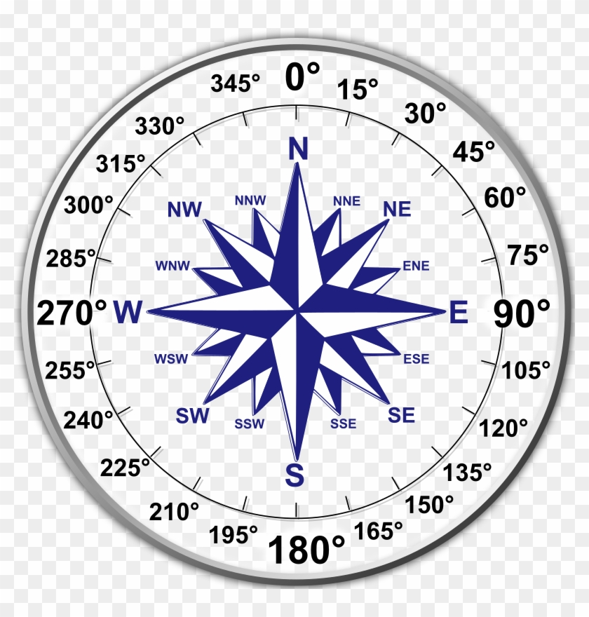
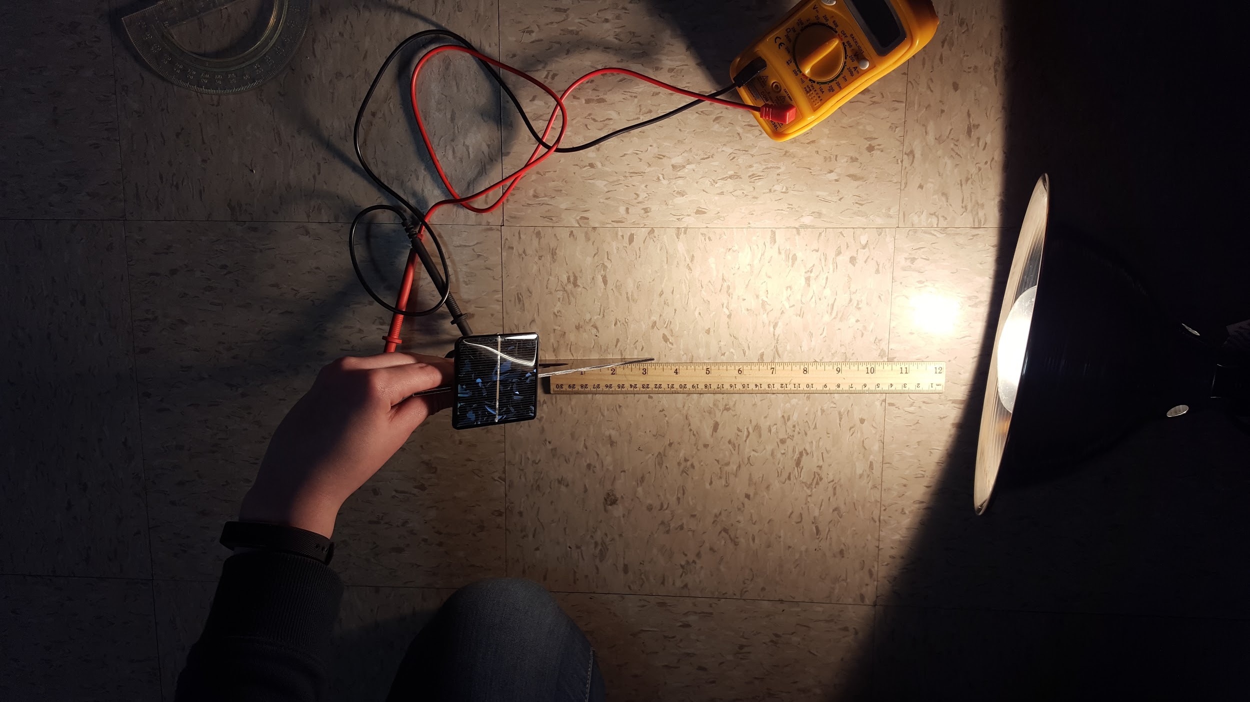
Example lab set-up Compass rose

Data Collection:
Table 1. Voltage at tilts and azimuths.
 | Azimuth
 | N | NE | E | SE | S | SW | W | NW
Tilt | 0 | 45 | 90 | 135 | 180 | 225 | 270 | 315
0 | 1.5 | 1.5 | 1.5 | 1.5 | 1.5 | 1.5 | 1.5 | 1.5
30 | 1.0 | 1.0 | 1.2 | 1.5 | 1.6 | 1.5 | 1.3 | 1.0
45 | 1.0 | 1.0 | 1.0 | 1.5 | 1.5 | 1.5 | 1.0 | 1.0
60 | 1.0 | 1.0 | 1.1 | 1.6 | 1.6 | 1.5 | 1.2 | 1.0
90 | 1.1 | 1.1 | 1.2 | 1.6 | 1.6 | 1.6 | 1.2 | 1.1

Table 2. Percent change of voltage output with tilt
 | Azimuth
 | N | NE | E | SE | S | SW | W | NW
Tilt | 0 | 45 | 90 | 135 | 180 | 225 | 270 | 315
0 - 30
30 - 45
45 - 60
60 - 90
90 - 0

Table 3. Percent change with voltage output azimuth
 | Azimuth
 | N | NE | E | SE | S | SW | W | NW
Tilt | 0-45 | 45-90 | 90-135 | 135-180 | 180-225 | 225-270 | 270-315 | 315-0
0
30
45
60
90

Table 4. Annual solar radiation gains from a DC system 16 Notes on the data:
 | Azimuth
Tilt | 0 | 90 | 180 | 270
0 | 4.47 | 4.47 | 4.47 | 4.47
30 | 2.99 | 4.24 | 5.21 | 4.2
45 | 2.26 | 3.98 | 5.16 | 3.92
60 | 1.65 | 3.64 | 4.83 | 3.58
90 | 1.17 | 2.78 | 3.47 | 2.72

Table 5. Percent change of solar radiation with tilt Notes on the data:
 | Azimuth
 | N | E | S | W
Tilt | 0 | 90 | 180 | 270
0 - 30
30 - 45
45 - 60
60 - 90
90 - 0

Table 6. Percent change of solar radiation with azimuth Notes on the data:
 | Azimuth
Tilt | 0-90 | 90-180 | 180-270 | 270-0
0
30
45
60
90

On a seperate piece of graph paper:
- Graph the relationship between the volts and tilt
- Graph the relationship between the volts and azimuth
- Graph the relationship between the annual solar radiation gains and the tilt
- Graph the relationship between the annual solar radiation gains and the azimuth

Conclusion:
1) What was the overall purpose of this experiment?

2) How is voltage output affected by tilt?

3) How is voltage output affected by azimuth?

4) How are annual solar gains affected by tilt?

5) How are annual solar gains affected by azimuth?

6) Based on the data, is there a change in tilt that has a greater impact on output than another? If so, which tilt and at what azimuth?

7) Based on the data, is there a change in azimuth that has a greater impact on output than another? If so, which tilt and at what azimuth?

8) Was your hypothesis related to tilt supported by data? Why or why not?

9) Was your hypothesis related to azimuth supported by data? Why or why not?

10) Where could errors in your data collection occurred?

11) How could this experiment be improved?

12) What could be studied next (related to variables that impact voltage output)?

