- What is the difference between climate and weather?

- What is climatology?

- How is climate studied? And how do scientists know that the climate has changed over time?

- What tools are used to forecast the weather?

- How have new technologies advanced meteorology?

- Why is weather forecasting important?

- What are some factors that affect a planet’s climate?

- What is the Earth’s atmosphere composed of?

- Why is the atmosphere so important?

- Identify the layers of the Earth’s atmosphere. Include the distances from the Earth’s surface.
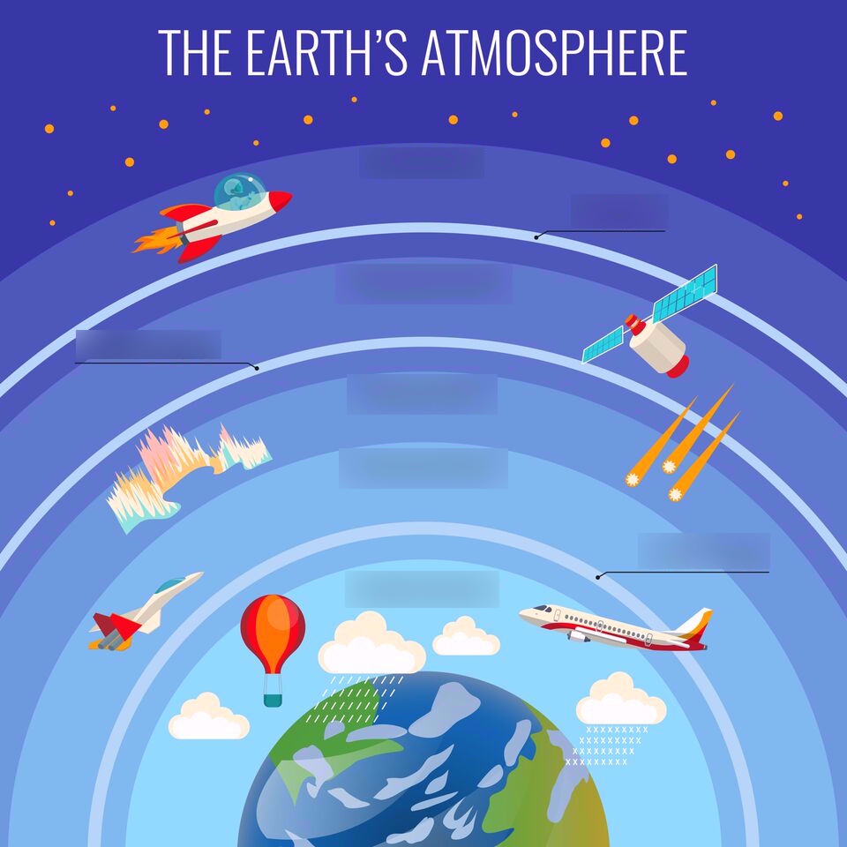

11) What can different types of clouds tell us about the weather?

