Wind Mills
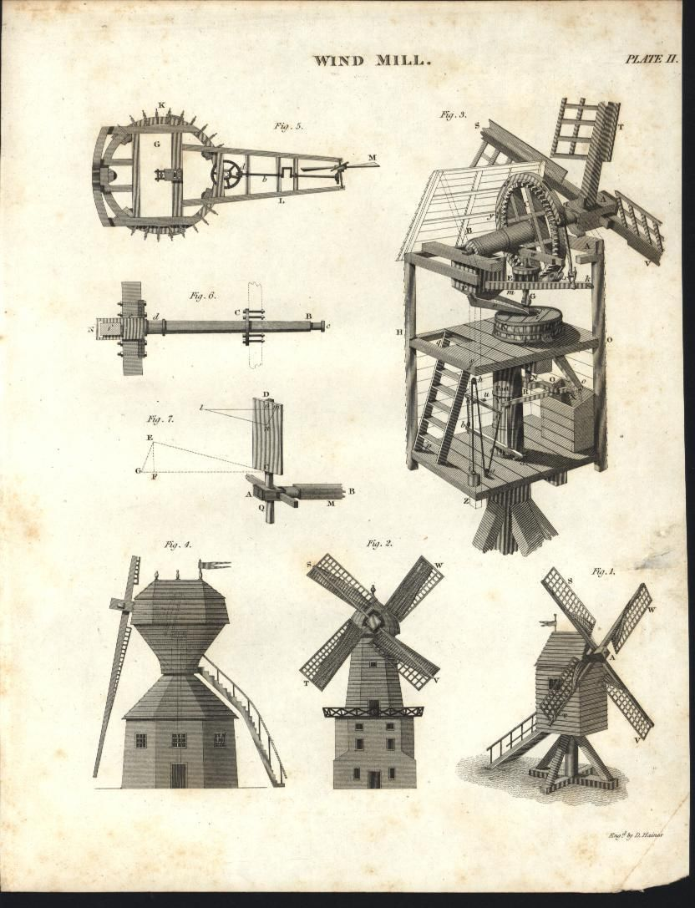
Objective: You will be provided with materials to design and construct a windmill. You will use the windmill to pull as much weight (washers) as far as possible.

Background:
What is a windmill?

Draw and label the parts of a windmill. Use the following vocabulary words in your diagram: blade; blade pitch; driveshaft; hub; plane of rotation; rotor

How does a windmill work?

Materials:
- 1 paper plate  - 6, 4” x 6” index cards  - 2 shish kebab skewers  - 1 straw  - 3” foam ball  - 4 stick-pins | - 4’ string  - 1 3-oz. cup  - 18” of masking tape  - 1 rubber band  - 1 cork
Design:
Draw a diagram of your windmill design in the space below. Label the following parts: blades, rotor, hub, driveshaft. Label these concepts: force, friction, distance (height of string).

Conclusion: Write your answer in complete sentences and include the question in the answer.
1.) What was the overall purpose of this challenge?

2.) Which of the following variables did you explore? Number of blades, blade shape, blade size, blade pitch (angle), fan location, wind speed, other (explain).

3.) Rank the variables in your design from most important to least important.

4.) What effect did the number of blades have on how much weight your windmill could lift? Did more blades mean you could lift more weight?

5.) How did the pitch (angle) of the blades affect the amount of weight your windmill could lift?

6.) Where did you attach the string? Why?

7.) How did your design change after the attempt to lift weight?

8.) What problems did you encounter?

9.) What parts of your windmill broke or failed?

10.) Explain the windmill design that had the best results. Why do you think this design worked best?

