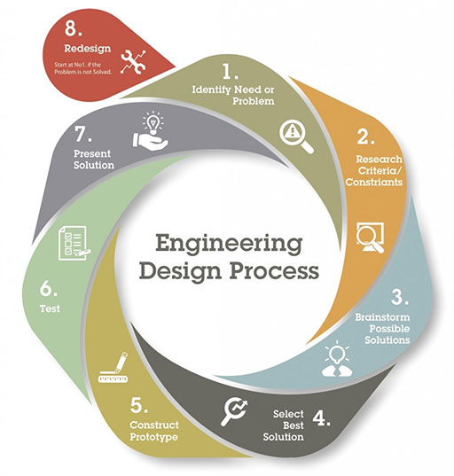
Name: ______________________________ Engineering Design Process 3-6

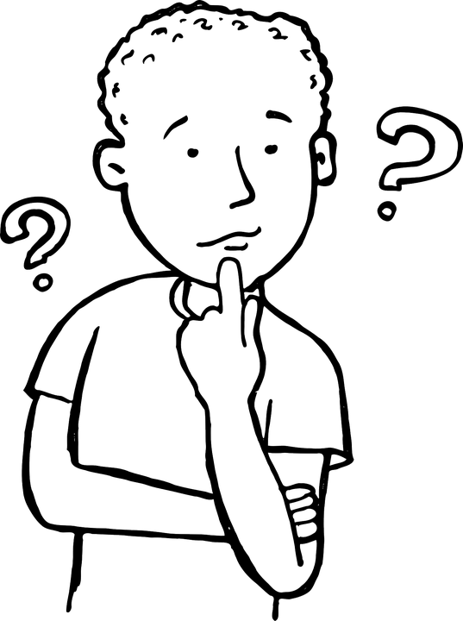

1. IDENTIFY: What is the real-world need or problem you want to solve?

2. RESEARCH: List any constraints or criteria for success? Such as materials, time, and cost.

Constraints: Limitations of materials and resources | Criteria: Desired features of a solution
Possible research questions: Ex. How have others solved this problem?

- ________________________________________________________
- ________________________________________________________
- _______________________________________________________

3. BRAINSTORM: What are possible solutions? ALL ideas are welcome.

1 | 2
3 | 4

4. CHOOSE: Select best solution.
PLAN: This is what I plan to build. Label all parts of your design.

What will we need to create your solution?: Ex. Materials and Resources

What are your controlled variables, or what are you keeping the same in each trial?
______________________________________________________________________________
__________________________________________________________________________________________________________________________________________________________________________________________________________________________________________
How many trials will your prototype undergo? ____________________________________________

5. BUILD: It’s time to construct your prototype!
6. TEST YOUR DESIGN:
COLLECT DATA: Use a table, graph, or written observations to record your findings.

7. PRESENT YOUR SOLUTION: Record feedback from your audience. Note what worked well and where improvements are needed.

What Worked Well | Improvements Needed

IMPROVE: Using your evidence, how could you improve your design to make it better?
- What works?
- What doesn’t work?
- What could work better?

8. Here is my REDESIGN PLAN:

Need any new materials?

RETEST: Does your new design work better? Record evidence to support your claim.

DATA: Use a table, graph, or written observations to record your findings.

REFLECT and ANALYZE : Did you solve your problem? What did you learn? Use ALL available evidence from your tests to describe whether or not you met your design challenge, even some that may work against your solution.

Our problem is…...
The best solution is…..
The evidence shows...
In most cases we saw...
Sometimes, however...
Our solution met the criteria by…..
Our solution did not meet the criteria by...
As you can see, our testing suggests this solution...
If given more time and resources, we would try...

Self-Reflection
______________________________________________________________________________
____________________________________________________________________________________________________________________________________________________________

Adapted from the Teaching Channel by Jessica Asp, Olga Mashnitskaya from the Edmonds School District.

