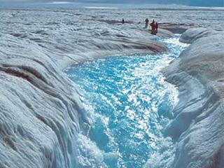
Shrinking ice sheets and Glacial Retreat
The Greenland and Antarctic ice sheets have decreased in mass. Data from NASA's Gravity Recovery and Climate Experiment show Greenland lost an average of 281 billion tons of ice per year between 1993 and 2016, while Antarctica lost about 119 billion tons during the same time period. The rate of Antarctica ice mass loss has tripled in the last decade.⁷
Image: Flowing meltwater from the Greenland ice sheet
Shrinking ice sheets

Ice sheets
- How has the mass of Antarctica and Greenland changed since 2004?

Global Ice Viewer
2) Look at various glaciers. What do you notice?

3) How has the annual minimum area of arctic sea ice changed since the late 1970’s?

