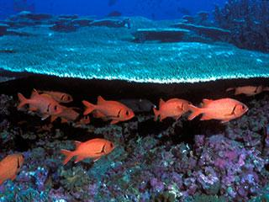
Ocean acidification
Since the beginning of the Industrial Revolution, the acidity of surface ocean waters has increased by about 30 percent.^{13,14} This increase is the result of humans emitting more carbon dioxide into the atmosphere and hence more being absorbed into the oceans. The amount of carbon dioxide absorbed by the upper layer of the oceans is increasing by about 2 billion tons per year.^{15,16}

The Other Carbon Dioxide Problem
- What is ocean acidification and why is it happening?

- How is the pH of the ocean studied and measured?

- Why is ocean acidification a concern?

