Name: ________________________ Period: __________ Date: __________________
Data Discussion for Patterns in Solar Cells
Research Question:
How does the angle between the ground and a given solar cell affect the it power produces?
Date: 3/20/2018 (Spring Equinox)  Location: Galapagos Islands (Latitude 0º)  Solar panel: size = 1 m x 1 m, Efficiency: 20% | Date: 3/20/2018 (Spring Equinox)  Location: Oregon (Latitude 45º N)  Solar panel: size = 1 m x 1 m, Efficiency: 30%
Equation: $Power = 100 cos (θ-0) + 100$ | Equation: $Power = 150 cos (θ-45) + 150$
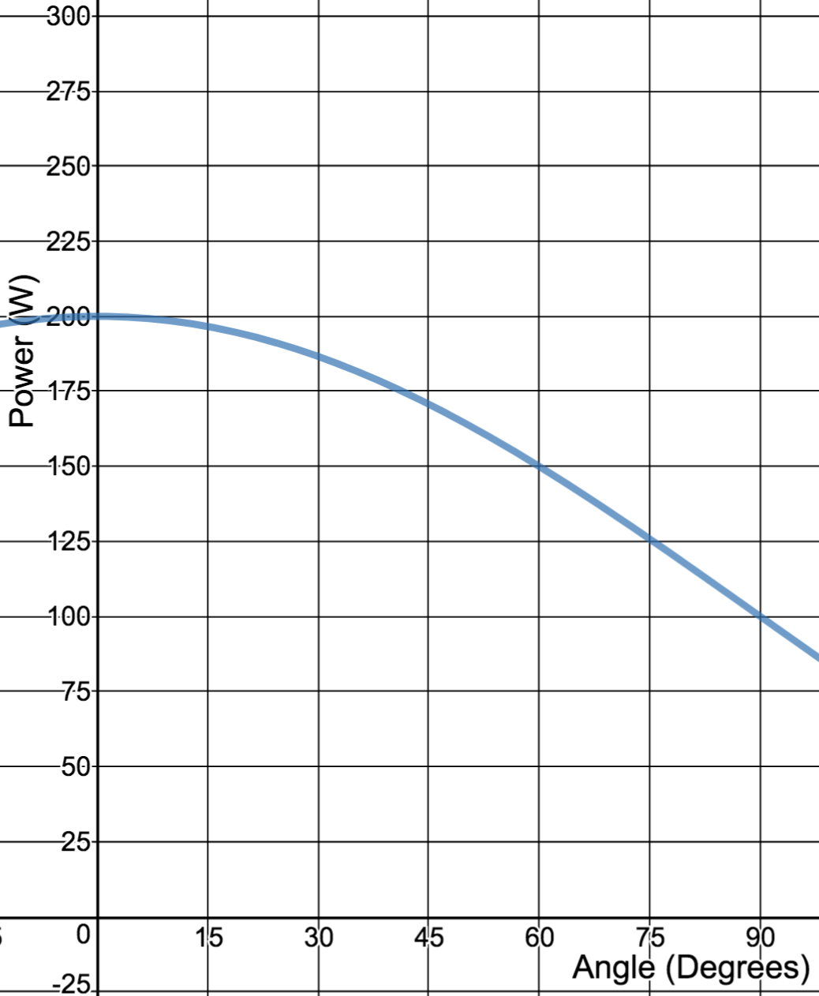 | 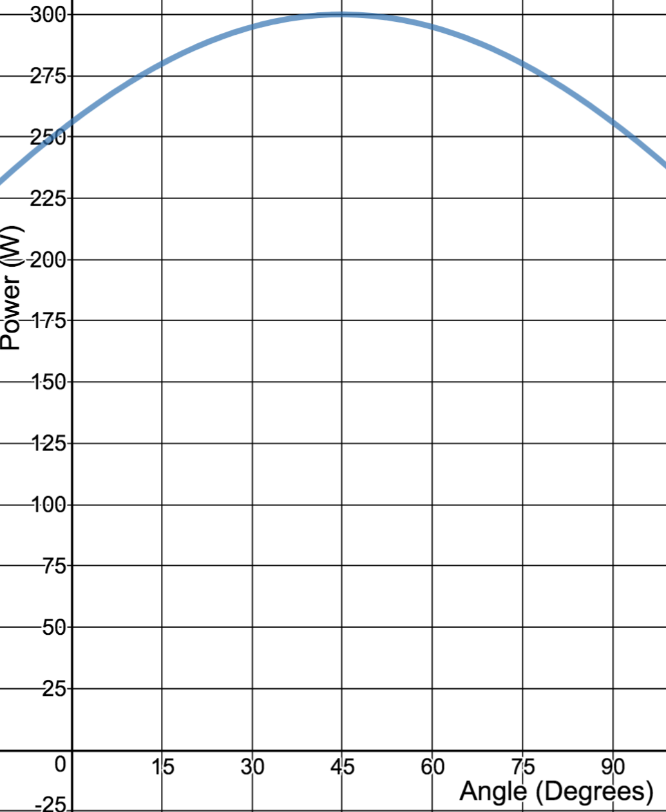
Date: 3/20/2018 (Spring Equinox)  Location: Alaska (Latitude 85º)  Solar panel: size = 1 m x 1 m, Efficiency: 20% | Date:  Location:  Solar panel:
Equation: $Power =100 cos (θ-85)+110$ | Equation:
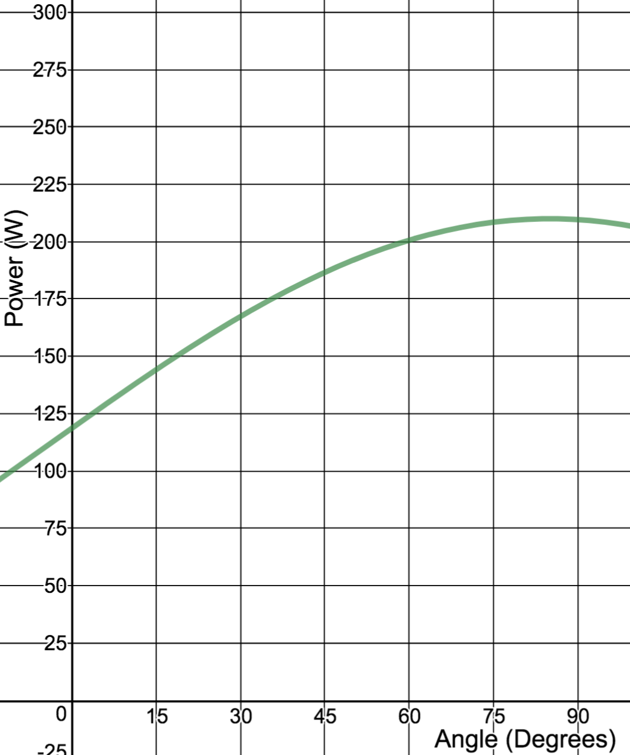

Similarities

Differences

Prediction Question 1: For the Galapagos solar panel display, what would the power be if you turned it upside down on the roof, that is 180º degrees? Why does this make sense? | Prediction Question 2: For the Alaska solar panel, if instead of tilting it towards the sun you tilted it backwards away from the -95º degrees what would the power be? How could it still be generating a little power?
Prediction 1: | Prediction 2:
At their respective optimum angles, why is Oregon’s solar panel producing more power than the Galapagos or Alaska solar panel?

In words with some annotated pictures, describe what the values mean the following contexts:
 | In the real world, it means | In the graph, it shows up as | In the mathematical model, it is
A
B
C
Write out the equation using all words (concepts):

Engineering Design Question:
How could you modify a solar panel to increase the effective A, B, and C values?
For A: | For B: | For C:

